JANATA SHIKSHAN SANSTHA’S

KISAN VEER MAHAVIDYALIYA WAI

(DEPARTMENT OF BCA)

2022-2023



A

PROJECT REPORT ON

“**Go-mart application**”

With special reference to submitted to

SHIVAJI UNIVERSITY, KOLHAPUR.

For the partial fulfilment of requirement for the award of degree of,

“BACHELOR OF COMPUTER APPLICATIONS”

(B.C.A-II)SEM-IV

BY-

1) Sayyad abrar nisar

2)Kumail abass

UNDER THE GUIDANCE OF

MRS T.S JAMDADE

JANATA SHIKSHAN SANSTHA’s KISAN VEER

MAHAVIDYALIYA WAI

(DEPARTMENT OF BCA)

2022-2023



CERTIFICATE

SEAT NO:- DATE: / /2023

This is certifying that project report entitled” Go-mart application” has been carried out by Sayyad Abrar Nisar and Kumail abass

In the partial fulfilment of requirement of S.Y.B.C.A semester-IV under SHIVAJI UNIVERSITY, KOLHAPUR.

To best of my knowledge and belief the presented information in this project that has submitted at its own time.

Project Guide External Examiner

Head of Department

Declaration:-

To,

The Principal,

Kisan Veer Mahavidyalaya, wai.

Respected Sir,

We under signed here by declare that the project entitled” Go-mart application”. Under the guidance of Mrs **T.S.Jamdade** & Submitted to Shivaji university , Kolhapur . For the partial fulfilment of the requirement of the award of the degree of “BACHELOR OF COMPUTER APPLICATION”.(SEM-IV) written & submitted by is our original work.

The empirical findings in the report are based on the data collected by us

For preparing the project .we have not copied from any source ,we understand that any coping is liable to punish in a way the university authority deem fit.

Yours Sincerely,

1. Sayyad abrar nisar

2. Kumail abass

Date:- / /2023

Place:-Wai

ACKNOWLEDGEMENT

We are thankful to **Mrs A.S Kadam**. Head of B.C.A Department,

Kisan veer Mahavidyalaya, wai for making available all the required resources and co-operate in our project work.

It gives us great pleasure to express gratitude to guide

We also thankful for our principal **& our coordinator** of BCA department.

For their valuable guidance and suggestion while preparing this project. We wish to express my sincere thanks to the principal ,Head of B.C.A Department ,and all teaching and non-teaching staff.

We are especially thanks to those who helped us directly –indirectly in

Completion of this work successfully.

Date: / /2023

Place:-Wai

Yours Sincerely

1. Sayyad abrar nisar

2. Kumail abass

Student Guide Report

|  |  |  |
| --- | --- | --- |
| Title of Project | go-mart application | Class: S-Y-BCA |
| Student Name: | 1. **Sayyad abrar nisar** 2. **Kumail abass** | Guide Name:  **Mrs A.S Kadam** |

|  |  |  |  |  |  |
| --- | --- | --- | --- | --- | --- |
| **Sr** | **Date** | **Description** | **Signature of Guide** | **Signature of Student** | **Guide Remark** |
| 1 | / /2023 | Problem Identification and topic and title finalization(1st  Week of semester) |  |  |  |
| 2 | / /2023 | SRS submission and approval (6th week of semester) |  |  |  |
| 3 | / /2023 | Logical Design of system (DFD< system flowchart,ERD,UML  Diagram,Descision tables ,Decision tree,site map which is applicable)  (7th week of semester) |  |  |  |
| 4 | / /2023 | Database design  (8th week of semester) |  |  |  |
| 5 | / /2023 | I/O Design (with reports)(10th semester) |  |  |  |
| 6 | / /2023 | Submission of Draft Project report(11th week of semester) |  |  |  |
| 7 | / /2023 | Submission of final project report(12th week of semester) |  |  |  |

**INDEX**

|  |  |  |
| --- | --- | --- |
| **Sr.no** | **Title** | **Page no** |
| 1 | **Introduction to project**  1.1)Introduction  1.2)Existing system  1.3)Need of computerization  1.4)scope of the system |  |
| 2 | **Proposed System**  2.1)Objectives  2.2)Requirement Gathering  2.3)Interview  2.4)Feasibility Study |  |
| 3 | **Implementation**  3.1)Hardware  3.2)Software |  |
| 4 | **System Design**  4.1)ERD and DFD  4.2)Activity Diagram & Case Diagram  4.3)Structure  4.4)Database design  4.5)Output Design |  |
| 5 | **Conclusion**  5.1)Conclusion  5.2)Limitation |  |
| 6 | **Bibliography**  6.1)Books  6.2)periodicals & Newspapers  6.3)Website |  |

**Introduction to project**

* 1. **Introduction**

The Project go-mart application is related to digital marketing which helps owners as well as sellers to make go-mart in efficient way.

The application provide login page in which we can login as admin or seller with valid id and password is needed. When we login as admin we can control all the things like category (admin can add any type of category products like laptop) ,then what type of category product is added ,then selling form is given which is shown when we login as seller (in this we can sell any product that we are having in stock and we can add bill and all the total of products sell by seller and also we are are having selling list).

Then admin can add many admins and sellers by unique id and password. New admin and seller can login easily by valid id password.

We are also having about section in which it is mentioned about application and developer’s.

And at last we are having exit button .this application will help owners and their sellers by providing them stock list and selling list.

This application is easy and reliable to use, anyone can use it efficiently. This application helps to minimize time and money of users by providing category of products and products also updating records and deleting them easily .this application provides security for both admin and seller.

**1.2) Existing System**

The drawbacks of existing system are as follows:

1. Existing System is difficult to understand.
2. Existing System takes more time for work,it was wasting process.
3. Existing System does not provide security.
4. Existing System Generate many Errors.
5. Existing System is based on paper documentary.
6. User faces many errors.

**1.3) NEED FOR COMPUTERIZATION**

1. Application Will be globally use by everyone.
2. To provide make go-mart modern.
3. Reduce the work of paper.
4. No loss of data as like paper based data.
5. It will help in saving all details about products and seller can sell eaisly.
6. Save time, money and paper.
7. Use of new technologies.
8. Use of computerized help in developing country.
9. The data save in computer in quality assurance.
10. The data in computer can be adjusted Dynamically.
11. It is cost effective.

**Scope of the System**

The go-mart application is having scope as under:-

1. Data is protected.
2. User valid needs username and password.
3. Admin has power to add or remove admins as well as sellers.
4. It makes data in accurate format.
5. Reduce time and work load.
6. All data is save and can be updated any time.
7. Admin can add the stock and update the stock.
8. There is mentioned about application and developers also.
9. Seller can make bills od sell products and also there is sell list.
10. It is fast and secure application.

Admins are login automatically when username and password are correct.

* Sellers are login automatically when username and password are correct.
* Seller can only sell the products and make bills of products which are sell .
* Admin can add or remove any admins and sellers.
* Saller can simply search which product is available in stock and how much quantity we are having.
* There is also information about application and developer.
* This is secure application.
* Admin is power to remove any user.
* It is reliable application that is understood by anyone.

**2.Proposed System**

The use of proposed system is to improve facility which is not available in existing system. The Proposed system will help in development and use of new technology.

The proposed System will provide data security .And avoid use of unauthorized access. The Proposed system will help in reduce the paper document as the documents will the computerized proposed system is user friendly which can be handled easily. Our application will make data in efficient minor and makes admin to secure all the data and can add or remove any data by own. Admin has power to add new admin and new user simply and remove any existing user. This application Provides facility to change as per demand.

**2.1) OBJECTIVES OF SYSTEM**

1. Our system is user friendly.
2. Proper information is displayed.
3. Screens are quite simple & easy to understand.
4. Our application is Multiuser system.
5. Saves the time of digital marketers.
6. Our application is simple & easy to understand.
7. Our application is easy to access to everyone.
8. In our application you can add new admin and new seller.

**2.2) REQUIRMENT GATHERING**

**Observation:**

Observation means to observe the working of existing system. To know there drawback and overcome them.

We are going the all existing system and introduce a new system. There are many other fact finding technique like interview, record view, But observation is best technique they it is why because in questionery and interview that developer will not get pin details as well as all question may not be covered.

Questionnaires:-

* 1. What are the drawbacks of system?
  2. Show process of old method of advertisement ?
  3. Purpose of the advertisement and the basic requirements?
  4. Which are modern technical requirements and expectations?
  5. What are your opinion about advertisement you’re your satisfaction level?

2.3)**Interview**

This interview is face to face communication for a specific purpose. Interview refers to any planned conversation with a specific purpose involving two people .The purpose of interview is ascertain the views attitudes and ideas of the person being interviewed. The process of interview is controlled by the interviewed .He schedules the interview in and poses a series of questions of elicit .The desired information from interviewer to interviewer until the objective is achieved.

The interview are held for various purposes. Each of interview has a definite purpose which is known both to the interviewer and interview. An interviewer is planned event. The day, time and place of interview is decided in advance.

Existing site are time consuming. Proposed system user friendly. The

New website is not complicated, simple and easy to use.

**2.4)Feasibility Study**

Feasibility Study is a process of evaluating the deciding factors to check whether proposed system is feasible or not.Feasibilty Study is the measure of a how beneficial or practical the development of an information system will be to an organization. The feasibility study is carried out in the fallowing aspects.

1. Technical Feasibility
2. Operational Feasibility
3. Economical Feasibility

**1) Technical Feasibility**

It is the measure of the practicality of a specific technical solution and the availability of the technical resources and expertise.

The technical requirements of the system are Windows11, Microsoft Visual Studio 2019 and Microsoft SQL Server 2009 R2.

**2)Operational Feasibility:-**

It is measure how well a solution will work on every university. It is also a measure of how students feel about system project. university achieve paperless concept, which are achieved through computerization which will cut down manual working of staff who work in the university.

**3) Economic Feasibility:-**

It is a measure of the cost effectiveness of a project. This is often called a Cost Benefit Analysis. The software & hardware required for this system is easily available. No additional cost will be incurred. The system will also reduce lots of paper work, chances of error & provide consistent information.

**3. IMPLEMENTATION**

**SYSTEM REQUIREMENT**

**3.1) Hardware Requirements**

* **Processor** : Pentium IV
* **Ram**  : 2GB
* **Hard Disk** : Minimum 630 MB
* **Keyboard** : 105 keys
* **Mouse**  : VIP
* **Printer** : LaserJet & color Printer

**3.2) Software Requirements**

* **Front End** : Visual studio 2019
* **Back End** : SQL server 2019.
* **Operating System** : Windows 11
* **Browsers**  : Internet explorer, Google Chrome
* **Server**  : Microsoft SQL server 2019 R2

**3.) System design**

**4.1)ERD & DFD**

**Entity Relationship Diagram:-**

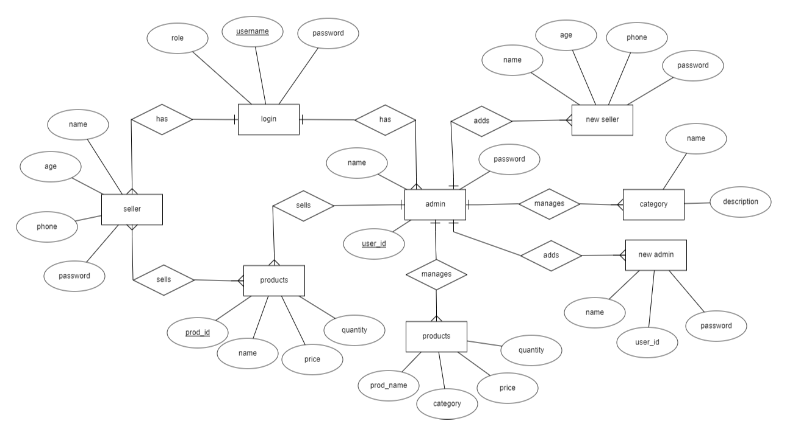

**DFD**

**Dataflow Diagram:-**

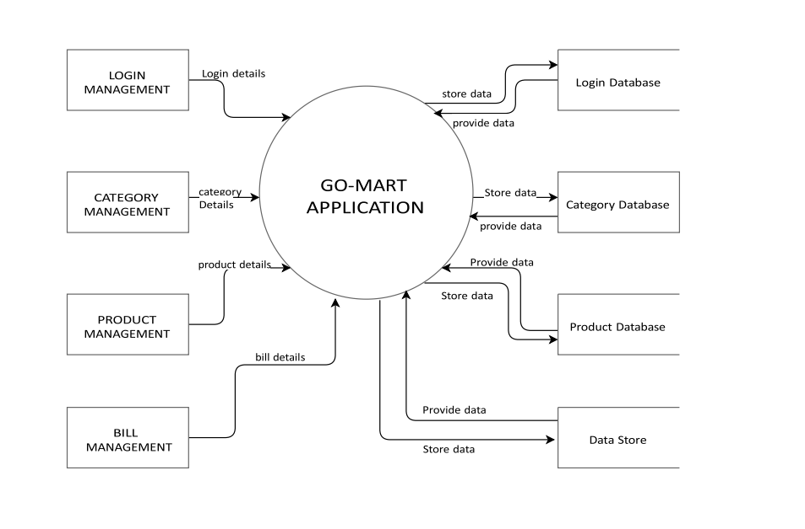

Database Tables

Admin:-

|  |  |  |  |
| --- | --- | --- | --- |
| **Field Name** | **Data Type** | **Constraint** | **Description** |
| Adminid | nvarchar50 | pri | Admin |
| Password | nvarchar50 |  | Password |
| Fullname | nvarchar50 |  | Full Name |

Bill:-

|  |  |  |  |
| --- | --- | --- | --- |
| **Field Name** | **Data Type** | **Constraint** | **Description** |
| Bill_Id | int | pri | Sid |
| SellerId | nvarchar(50) |  | Student Name |
| SellDate | nvarchar(50) |  | Date of birth |
| Total | Varchar(50) |  | Gender |

Catagory:-

|  |  |  |  |
| --- | --- | --- | --- |
| **Field Name** | **Data Type** | **Constraint** | **Description** |
| CatId | Int | pri | Category Id |
| CatagoryName | Nvarchar(50) |  | Category Name |
| CatagoryDesc | Nvarchar(50) |  | Category Desc |

Product:-

|  |  |  |  |
| --- | --- | --- | --- |
| **Field Name** | **Data Type** | **Constraint** | **Description** |
| ProdId | int | pri | Product Id |
| ProdName | nvarchar(50) |  | Product Name |
| ProdCatId | int |  | Product Category |
| ProdPrice | Decimal(10,2) |  | Price |
| ProdQty | int |  | Quantity |

Seller:-

|  |  |  |  |
| --- | --- | --- | --- |
| **Field Name** | **Data Type** | **Constraint** | **Description** |
| SellerId | int | pri | courseId |
| SellerName | nvarchar(50) |  | Course_name |
| SellerAge | int |  | Credit Hours |
| SellerPhone | nvarchar(50) |  | Dept Id |
| SellerPass | nvarchar (50) |  | Department Name |

**Output design:-**

**ADMIN PAGE:- Here admin can handle all the activities related to application.**

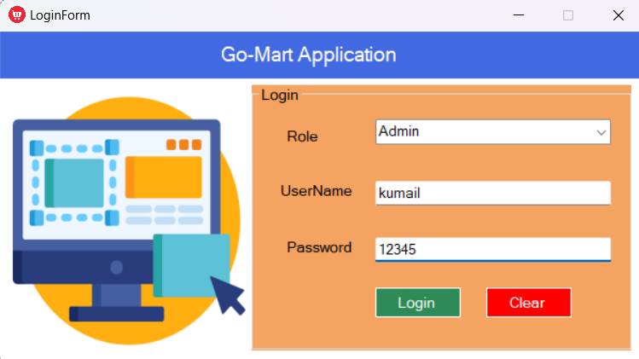

**SELLER:-Here seller can sell the products.**

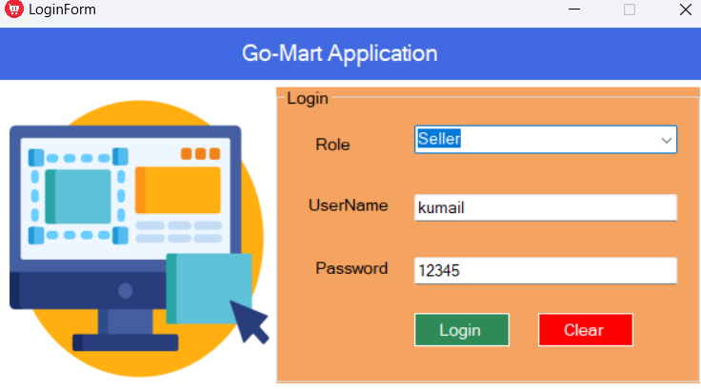

**HOMEPAGE:- This is the main page of application.**

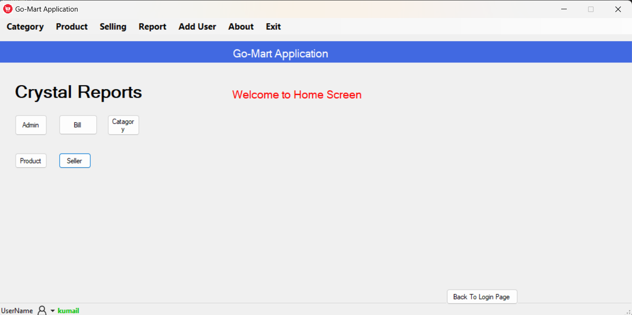

**CATEGORY:- Here admin can add category.**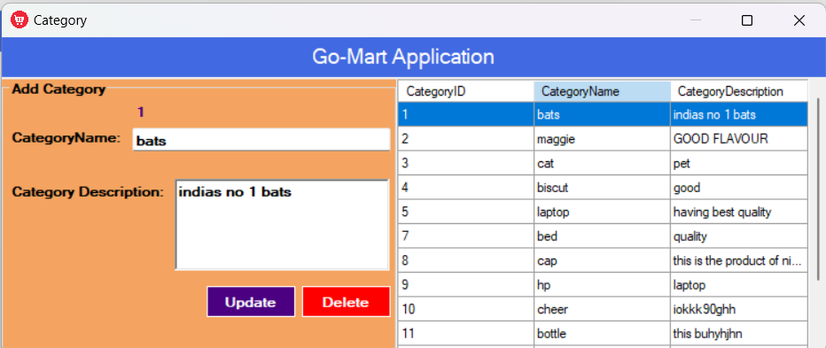

**PRODUCT:- Here products are added related to there category.**

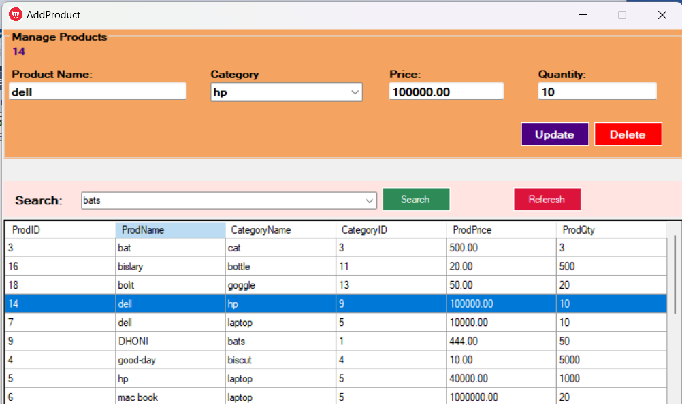

**ADD ADMIN:-here admin can add new admin.**

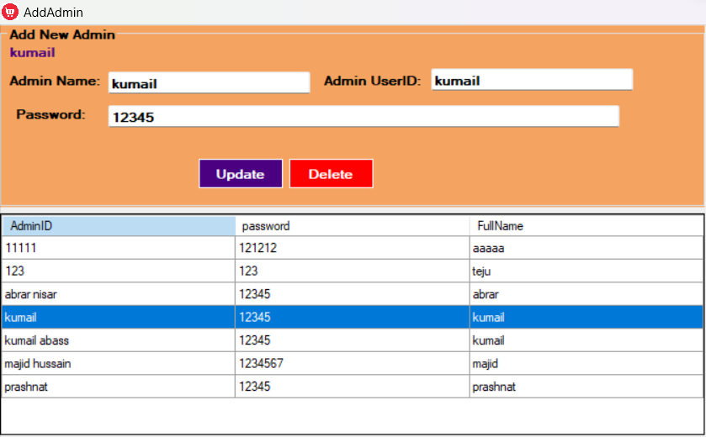

**ADD SELLER:-here admin can add new seller.**

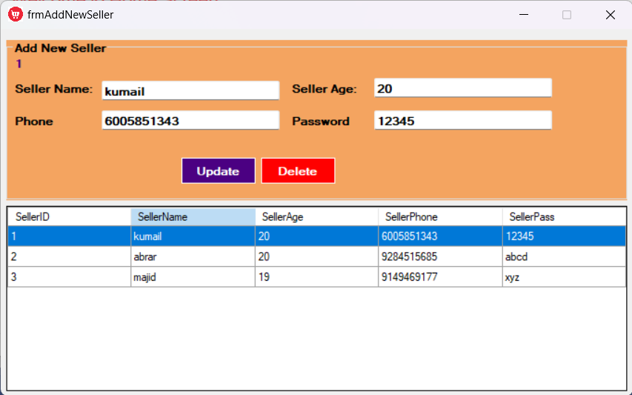

**ABOUT:-Here it is mentioned about app and devlopers.**

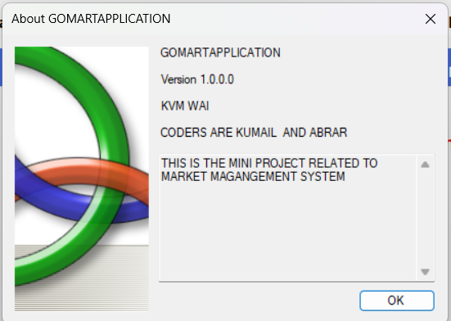

**Report Design:-**

**Admin:-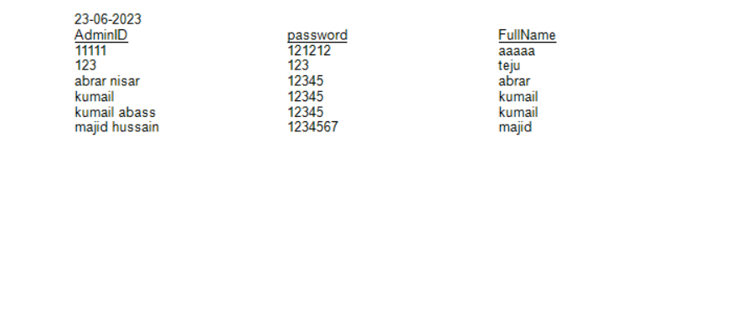2.Bill:-**

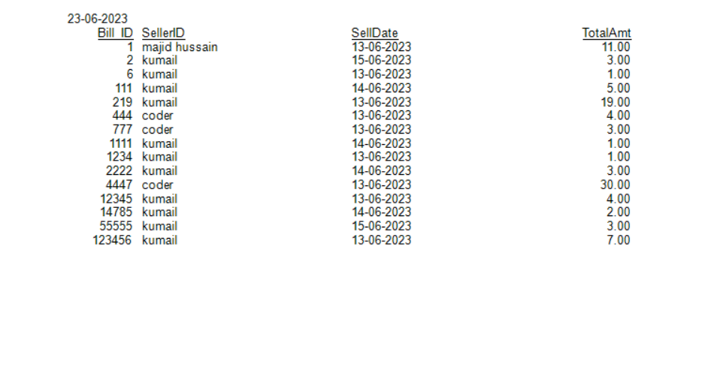

**3.Category:-**

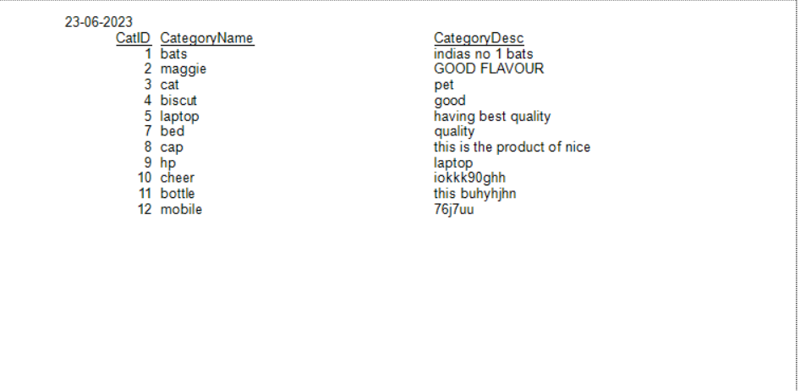**4.Product:-**

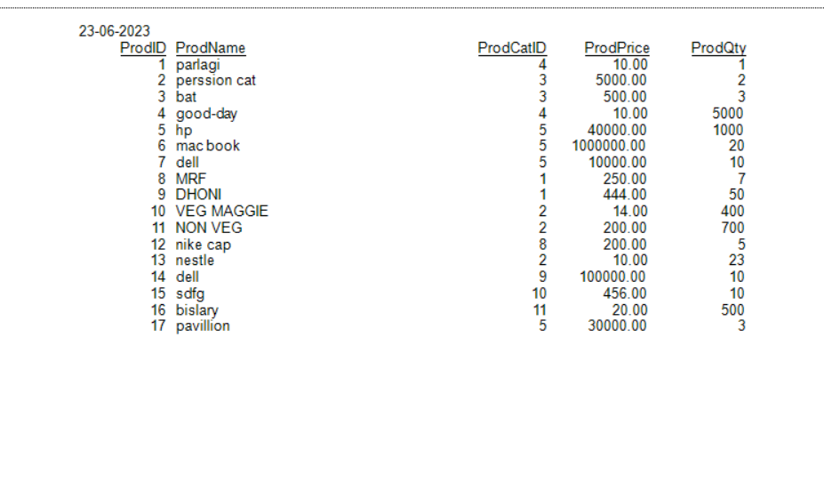**5.Seller:-**

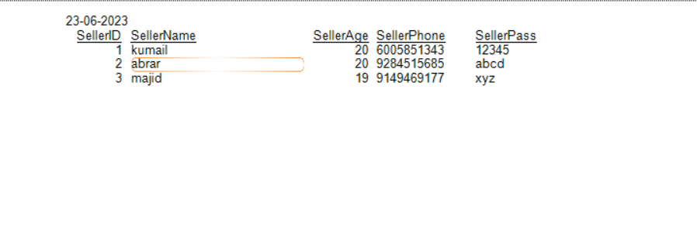

**5)Conclusion**

This application is economical, technical & as well as operational feasible. Data can be updated or deleted any time as per stock availability.

It is very user friendly. So that every user can handle it with easy. The application is developing such that it will not change the work flow of system, if some changes are suggested. This system provides facility to change as per demand.

**5.1) LIMITATIONS OF PROJECT**

* 1. Admin can add or remove any user.
  2. Valid username and password are required for login.
  3. Admin can add products and remove products.
  4. Seller cannot make any changes.
  5. It is personal application.

**Future Modification:-**

**6.BIBLIOGRAPHY**

**6.1)WEBSITES**

**6.2)PERIODICAL & NEWSPAPERS**

**6.3)BOOKS**

[**www.google.com**](http://www.google.com)

[**www.bing.com**](http://www.bing.com)

**Source Code:-**

**1)Admin:-**

namespace GoMartApplication

{

partial class AddAdmin

{

/// <summary>

/// Required designer variable.

/// </summary>

private System.ComponentModel.IContainer components = null;

/// <summary>

/// Clean up any resources being used.

/// </summary>

/// <param name="disposing">true if managed resources should be disposed; otherwise, false.</param>

protected override void Dispose(bool disposing)

{

if (disposing && (components != null))

{

components.Dispose();

}

base.Dispose(disposing);

}

private System.Windows.Forms.GroupBox groupBox1;

private System.Windows.Forms.TextBox txtPass;

private System.Windows.Forms.Label label5;

private System.Windows.Forms.TextBox txtAdminID;

private System.Windows.Forms.Label label4;

private System.Windows.Forms.Label lblAdminID;

private System.Windows.Forms.Button btnUpdate;

private System.Windows.Forms.Button btnDelete;

private System.Windows.Forms.Button btnAdd;

private System.Windows.Forms.TextBox txtAdminName;

private System.Windows.Forms.Label label2;

private System.Windows.Forms.DataGridView dataGridView1;

}

}

**2)Bill:-**

namespace GoMartApplication {

using System;

using System.ComponentModel;

using CrystalDecisions.Shared;

using CrystalDecisions.ReportSource;

using CrystalDecisions.CrystalReports.Engine;

public class bill : ReportClass {

public bill() {

}

public override string ResourceName {

get {

return "bill.rpt";

}

set {

// Do nothing

}

}

public override bool NewGenerator {

get {

return true;

}

set {

// Do nothing

}

}

public override string FullResourceName {

get {

return "GoMartApplication.bill.rpt";

}

set {

// Do nothing

}

}

[Browsable(false)]

[DesignerSerializationVisibilityAttribute(System.ComponentModel.DesignerSerializationVisibility.Hidden)]

public CrystalDecisions.CrystalReports.Engine.Section Section1 {

get {

return this.ReportDefinition.Sections[0];

}

}

[Browsable(false)]

[DesignerSerializationVisibilityAttribute(System.ComponentModel.DesignerSerializationVisibility.Hidden)]

public CrystalDecisions.CrystalReports.Engine.Section Section2 {

get {

return this.ReportDefinition.Sections[1];

}

}

[Browsable(false)]

[DesignerSerializationVisibilityAttribute(System.ComponentModel.DesignerSerializationVisibility.Hidden)]

public CrystalDecisions.CrystalReports.Engine.Section Section3 {

get {

return this.ReportDefinition.Sections[2];

}

}

[Browsable(false)]

[DesignerSerializationVisibilityAttribute(System.ComponentModel.DesignerSerializationVisibility.Hidden)]

public CrystalDecisions.CrystalReports.Engine.Section Section4 {

get {

return this.ReportDefinition.Sections[3];

}

}

[Browsable(false)]

[DesignerSerializationVisibilityAttribute(System.ComponentModel.DesignerSerializationVisibility.Hidden)]

public CrystalDecisions.CrystalReports.Engine.Section Section5 {

get {

return this.ReportDefinition.Sections[4];

}

}

}

[System.Drawing.ToolboxBitmapAttribute(typeof(CrystalDecisions.Shared.ExportOptions), "report.bmp")]

public class Cachedbill : Component, ICachedReport {

public Cachedbill() {

}

[Browsable(false)]

[DesignerSerializationVisibilityAttribute(System.ComponentModel.DesignerSerializationVisibility.Hidden)]

public virtual bool IsCacheable {

get {

return true;

}

set {

//

}

}

[Browsable(false)]

[DesignerSerializationVisibilityAttribute(System.ComponentModel.DesignerSerializationVisibility.Hidden)]

public virtual bool ShareDBLogonInfo {

get {

return false;

}

set {

//

}

}

[Browsable(false)]

[DesignerSerializationVisibilityAttribute(System.ComponentModel.DesignerSerializationVisibility.Hidden)]

public virtual System.TimeSpan CacheTimeOut {

get {

return CachedReportConstants.DEFAULT_TIMEOUT;

}

set {

//

}

}

public virtual CrystalDecisions.CrystalReports.Engine.ReportDocument CreateReport() {

bill rpt = new bill();

rpt.Site = this.Site;

return rpt;

}

public virtual string GetCustomizedCacheKey(RequestContext request) {

String key = null;

// // The following is the code used to generate the default

// // cache key for caching report jobs in the ASP.NET Cache.

// // Feel free to modify this code to suit your needs.

// // Returning key == null causes the default cache key to

// // be generated.

//

// key = RequestContext.BuildCompleteCacheKey(

// request,

// null, // sReportFilename

// this.GetType(),

// this.ShareDBLogonInfo );

return key;

}

}

}

**3)Category:-**

namespace GoMartApplication

{

partial class catagry

{

/// <summary>

/// Required designer variable.

/// </summary>

private System.ComponentModel.IContainer components = null;

/// <summary>

/// Clean up any resources being used.

/// </summary>

/// <param name="disposing">true if managed resources should be disposed; otherwise, false.</param>

protected override void Dispose(bool disposing)

{

if (disposing && (components != null))

{

components.Dispose();

}

base.Dispose(disposing);

}

#region Windows Form Designer generated code

/// <summary>

/// Required method for Designer support - do not modify

/// the contents of this method with the code editor.

/// </summary>

private void InitializeComponent()

{

this.crystalReportViewer1 = new CrystalDecisions.Windows.Forms.CrystalReportViewer();

this.CrystalReport131 = new GoMartApplication.CrystalReport13();

this.SuspendLayout();

//

// crystalReportViewer1

//

this.crystalReportViewer1.ActiveViewIndex = 0;

this.crystalReportViewer1.BorderStyle = System.Windows.Forms.BorderStyle.FixedSingle;

this.crystalReportViewer1.Cursor = System.Windows.Forms.Cursors.Default;

this.crystalReportViewer1.Dock = System.Windows.Forms.DockStyle.Fill;

this.crystalReportViewer1.Location = new System.Drawing.Point(0, 0);

this.crystalReportViewer1.Name = "crystalReportViewer1";

this.crystalReportViewer1.ReportSource = this.CrystalReport131;

this.crystalReportViewer1.Size = new System.Drawing.Size(800, 450);

this.crystalReportViewer1.TabIndex = 0;

//

// catagry

//

this.AutoScaleDimensions = new System.Drawing.SizeF(8F, 16F);

this.AutoScaleMode = System.Windows.Forms.AutoScaleMode.Font;

this.ClientSize = new System.Drawing.Size(800, 450);

this.Controls.Add(this.crystalReportViewer1);

this.Name = "catagry";

this.Text = "catagry";

this.ResumeLayout(false);

}

#endregion

private CrystalDecisions.Windows.Forms.CrystalReportViewer crystalReportViewer1;

private CrystalReport13 CrystalReport131;

}

}

**4)Product:-**

amespace GoMartApplication

{

partial class productsss

{

/// <summary>

/// Required designer variable.

/// </summary>

private System.ComponentModel.IContainer components = null;

/// <summary>

/// Clean up any resources being used.

/// </summary>

/// <param name="disposing">true if managed resources should be disposed; otherwise, false.</param>

protected override void Dispose(bool disposing)

{

if (disposing && (components != null))

{

components.Dispose();

}

base.Dispose(disposing);

}

#region Windows Form Designer generated code

/// <summary>

/// Required method for Designer support - do not modify

/// the contents of this method with the code editor.

/// </summary>

private void InitializeComponent()

{

this.crystalReportViewer1 = new CrystalDecisions.Windows.Forms.CrystalReportViewer();

this.CrystalReport141 = new GoMartApplication.CrystalReport14();

this.SuspendLayout();

//

// crystalReportViewer1

//

this.crystalReportViewer1.ActiveViewIndex = 0;

this.crystalReportViewer1.BorderStyle = System.Windows.Forms.BorderStyle.FixedSingle;

this.crystalReportViewer1.Cursor = System.Windows.Forms.Cursors.Default;

this.crystalReportViewer1.Dock = System.Windows.Forms.DockStyle.Fill;

this.crystalReportViewer1.Location = new System.Drawing.Point(0, 0);

this.crystalReportViewer1.Name = "crystalReportViewer1";

this.crystalReportViewer1.ReportSource = this.CrystalReport141;

this.crystalReportViewer1.Size = new System.Drawing.Size(800, 450);

this.crystalReportViewer1.TabIndex = 0;

//

// productsss

//

this.AutoScaleDimensions = new System.Drawing.SizeF(8F, 16F);

this.AutoScaleMode = System.Windows.Forms.AutoScaleMode.Font;

this.ClientSize = new System.Drawing.Size(800, 450);

this.Controls.Add(this.crystalReportViewer1);

this.Name = "productsss";

this.Text = "productsss";

this.ResumeLayout(false);

}

#endregion

private CrystalDecisions.Windows.Forms.CrystalReportViewer crystalReportViewer1;

private CrystalReport14 CrystalReport141;

}

}

**5)Seller:-**

namespace GoMartApplication

{

partial class SellingForm

{

/// <summary>

/// Required designer variable.

/// </summary>

private System.ComponentModel.IContainer components = null;

/// <summary>

/// Clean up any resources being used.

/// </summary>

/// <param name="disposing">true if managed resources should be disposed; otherwise, false.</param>

protected override void Dispose(bool disposing)

{

if (disposing && (components != null))

{

components.Dispose();

}

base.Dispose(disposing);

}

private System.Windows.Forms.Panel panel1;

private System.Windows.Forms.Label lblDate;

private System.Windows.Forms.Label label2;

private System.Windows.Forms.Label label1;

private System.Windows.Forms.Label label3;

private System.Windows.Forms.Label label4;

private System.Windows.Forms.Label label5;

private System.Windows.Forms.Label label6;

private System.Windows.Forms.TextBox txtProdID;

private System.Windows.Forms.TextBox txtProductName;

private System.Windows.Forms.TextBox txtPrice;

private System.Windows.Forms.TextBox txtQty;

private System.Windows.Forms.DataGridView dataGridView1_Order;

private System.Windows.Forms.Button btnAddOrder;

private System.Windows.Forms.ComboBox cmbCategory;

private System.Windows.Forms.Button btnRefCat;

private System.Windows.Forms.DataGridView dataGridView1;

private System.Windows.Forms.Label label7;

private System.Windows.Forms.Label label8;

private System.Windows.Forms.Label lblGrandTot;

private System.Windows.Forms.Button button2;

private System.Windows.Forms.Button button3;

private System.Windows.Forms.DataGridView dataGridView2_Product;

private System.Windows.Forms.DataGridViewTextBoxColumn ProdID;

private System.Windows.Forms.DataGridViewTextBoxColumn ProductName;

private System.Windows.Forms.DataGridViewTextBoxColumn Price;

private System.Windows.Forms.DataGridViewTextBoxColumn Quantity;

private System.Windows.Forms.DataGridViewTextBoxColumn Total;

private System.Windows.Forms.TextBox txtBillNo;

private System.Windows.Forms.Button btnAddBill_Details;

private System.Windows.Forms.Label label9;

}

}

**THANK YOU**